DeltaLambdaSigma ΔΛΣ

System Requirements Specification

|  |  |  |
| --- | --- | --- |
| DeltaLambdaSigma, Ivan Sekyonda, CEO | | |
| Rob Hiles | Matthew McHugh | Ben Yamada |
| Kes Johnson | Raj Karsalia |  |

Introduction

DeltaLambdaSigma is a web application that allows users to design and simulate digital logic schematics. The Web application will serve as a viable replacement for the aging Xilinx software. The application provides an interface for users to design circuits using components such as inputs, outputs, wires, gates, busses, etc. The application also provides a simulation interface for users to analyze the behavior of the circuit. The application also provides the functionality for the user to build and deploy their own symbols within the software.

Developer stories

Prerequisite Learning

#### **As a developer, I want to learn how to deploy a Django web application to the cloud.**

#### **As a developer, I want to learn how to build a pipeline for my web application.**

#### **As a developer, I want to figure out how to translate a graphical design/schematic to code.**

#### **As a developer, I want to figure out how to load/save a schematic design of a specific format (such as “.sch”).**

#### **As a developer, I want to figure out what file formats to use for schematics (.sch?) and for workbenches (.vhdl)**

#### **As a developer, I want to host a web application that will handle at least 80 users simultaneously.**

#### **As a developer, I want to be able to run a test schematic**

#### 

User stories

Schematic Design Interface

#### **As a user, I want to have a workplace for my designs**

* This is the main page where gates/other components can be placed.

#### **As a user, I want to have basic components**

* This will include gates such as or, and, xor, etc
* Wires
* Bus taps
* Max input size for gates is 8 bits
* Multiplexor with max size is 16 bits
* Buses with max size is 16 bits
* LEDs that display on the schematic

#### **As a user, I want to create my own components**

* Components can be made from a user's previous designs.

#### **As a user, I want to be able to place components**

* Components are able to be manipulated (size changes/rotations)
* Components are able to be different things (gates, wires, etc.)
* Copy and paste components

#### **As a user, I want to save my design to a file.**

* Export the schematic to the users local computer

#### **As a user, I want to import a file with my design.**

* Import the schematic from the users local computer

#### **As a user, I want to import a library with a series of designs.**

* Import the library from the users local computer

#### **As a user, I want to have a toolbar**

* Includes import/export buttons
* Simulation controls

#### **As a user, I want to have a toolbox**

* Includes component selection

Simulation Interface

**As a user, I want to simulate my design**

* Be able to take a given schematic and a given testbench and view the output

**As a user, I want to have a default testbench**

* System generates a default testbench if the user doesn’t supply one

**As a user, I want to be able to import a custom testbench (.vhdl)**

* System is able to accept a custom testbench to simulate design

**As a user, I want to view input/output waveforms from simulation**

* For example…

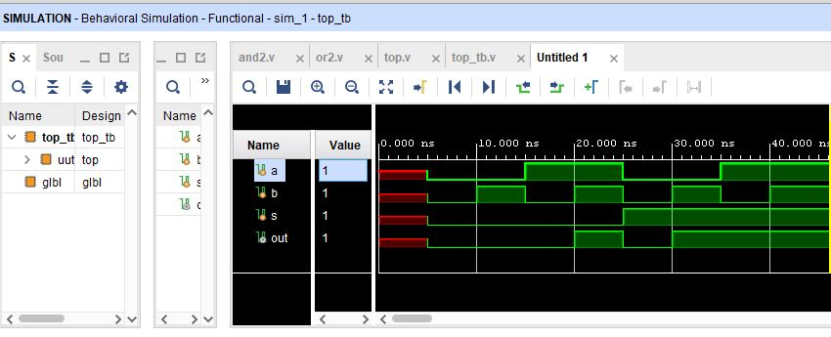

Story Backlog

1. As a developer, I want to learn how to deploy a Django web application to the cloud.
2. As a developer, I want to learn how to build a pipeline for my web application.
3. As a developer, I want to figure out how to translate a graphical design/schematic to code.
4. As a developer, I want to figure out how to load/save a schematic design of a specific format (such as “.sch”).
5. As a developer, I want to figure out what file formats to use for schematics (.sch?) and for workbenches (.vhdl)
6. As a developer, I want to host a web application that will handle at least 80 users simultaneously.
7. As a user, I want to have a workplace for my designs
8. As a user, I want to have basic components
9. As a user, I want to have a toolbox
10. As a user, I want to have a toolbar
11. As a user, I want to be able to place components
12. As a developer, I want to be able to run a test schematic
13. As a user, I want to save my design to a file.
14. As a user, I want to import a file with my design.
15. As a user, I want to simulate my design
16. As a user, I want to have a default testbench
17. As a user, I want to create my own components
18. As a user, I want to import a library with a series of designs.
19. As a user, I want to be able to import a custom testbench (.vhdl)
20. As a user, I want to view input/output waveforms from simulation

#### Development dependencies

* Backend components should be built before frontend/graphic components

#### Stakeholder dependencies

* Simulation functionality (Waveforms)
* Blackboxes/symbol creation
* Import/export functionality

Risk analysis

The main risk facing DeltaLambdaSigma is the developer’s inexperience with the Django framework, graphic design, and digital logic design. Besides that, we do not foresee any significant risks as a result of external factors.